Bitmap Images (100 Marks)

During the initial days of computer graphics, pictures happened to be black and white. These kinds of pictures can be made using only two colors - black and white. Following diagram shows such a picture.

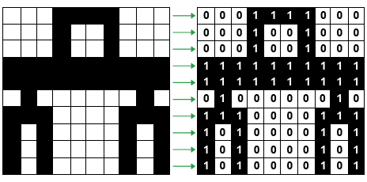

You are given two such pictures **A** and **B**. Each of these pictures is a matrix with dimensions **N x M** and each cell in them contains either **0** or **1**.

Your task is to find the minimum number of moves to transform matrix A into matrix B. A move consists of flipping (1 becomes 0 and 0 becomes 1) all elements of some contiguous **3 x 3** submatrix. If **A** cannot be transformed into **B**, **return -1.**

**Input Format**

The first line of input consists of 2 integers **N** - number of rows of given matrices, and **M** - number of columns of given matrices.

Following N lines consists of M integers each - either 0 or 1 representing matrix A.

Next line is  kept blank.

Following N lines consists of M integers each - either 0 or 1 representing matrix B.

**Constraints**

1 <= N, M <= 50

**Output Format**

A single line containing an integer which is the answer to the problem.

**Sample TestCase 1**

Input

1 1

1

0

Output

-1

Explanation

There is no way to select a 3 x 3 submatrix. So, we cannot make any move, and hence the matrix A remains unchanged.

**Sample TestCase 2**

Input

3 3

1 1 1

1 1 1

1 1 1

0 0 0

0 0 0

0 0 0

Output

1

Explanation

Select the complete matrix A (as it is already 3 x 3), and make a single move. A becomes same as B.

**Sample TestCase 3**

Input

3 4

0 0 0 0

0 0 1 0

0 0 0 0

1 0 0 1

1 0 1 1

1 0 0 1

Output

2

Explanation

For the first move select the 3 x 3 submatrix with top-left corner at (1,1) and for the second move select the 3 x 3 submatrix with top left corner at (1,2).